LOAN MANAGEMENT ASSESSMENT
CAPGEMINI
- Create Loan(post/loans)
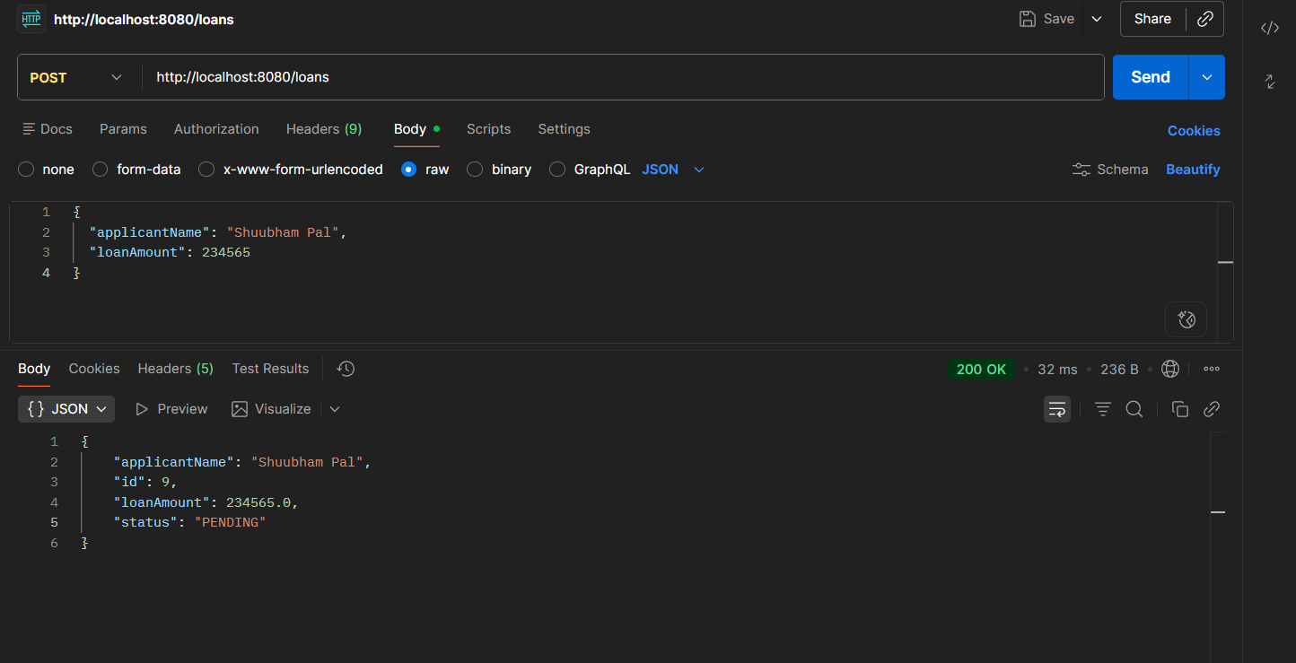
- GET ALL LOANS(GET/loans)
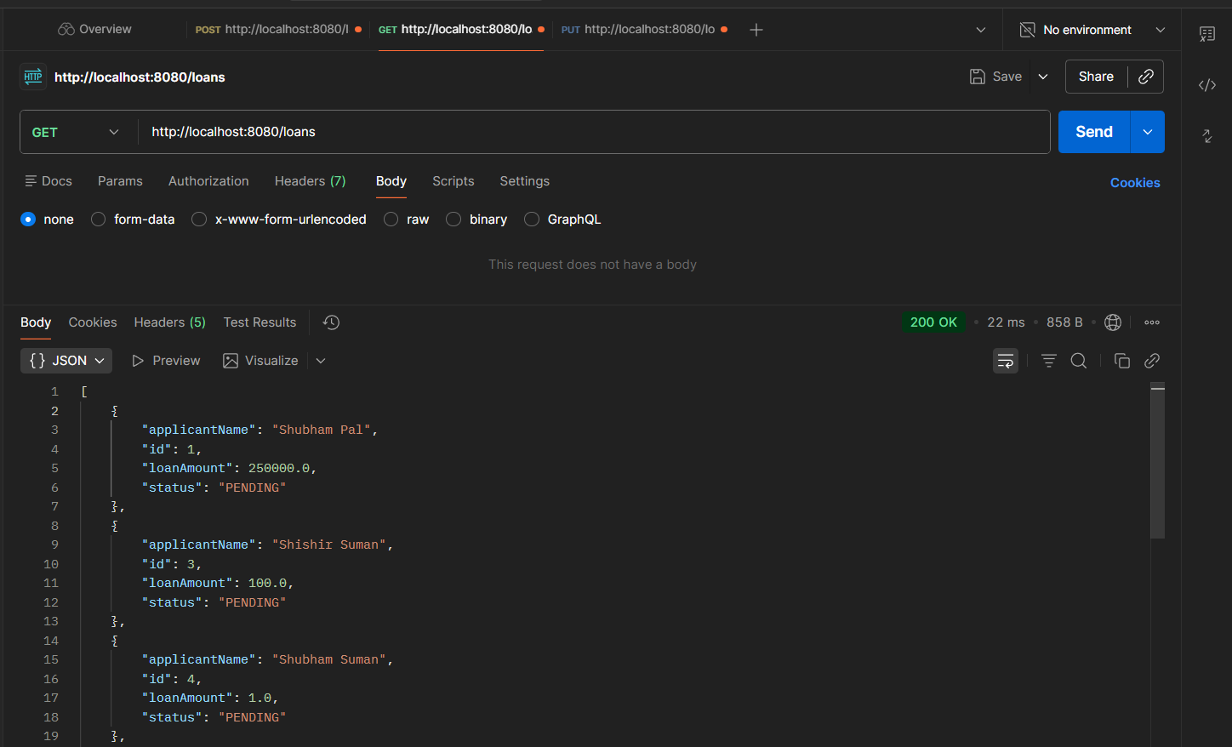
- Get Loan BY Id(GET/loans/{ID})
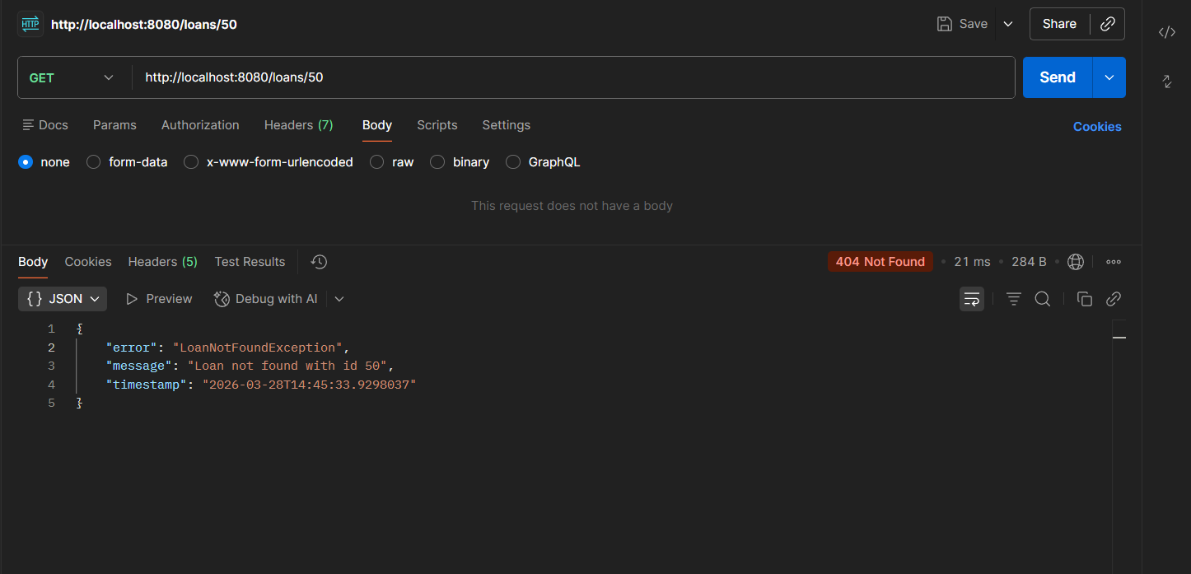
- Update Loan Status (PUT /loans/{id}/status)
